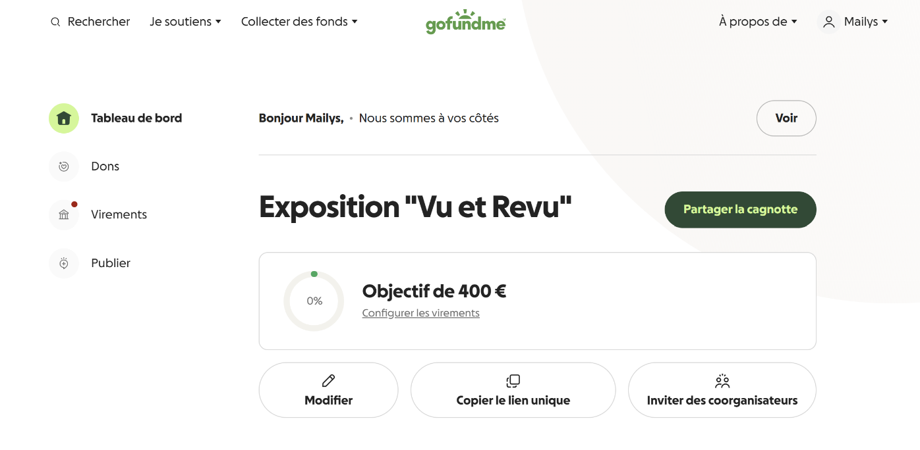

https://gofund.me/70780b2df

